Analisis para Cabezo en la comunidad pesquera Maria Elena

Table of Contents

# Resumen

**Leyenda**

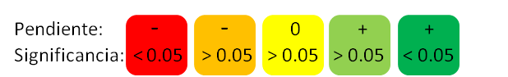

|  |  |  |
| --- | --- | --- |
| Clase de indicador | Indicador | Valor |
| Bio | Densidad Peces |  |
| Bio | Riqueza Peces |  |
| Bio | Biomasa Peces |  |
| Bio | Nivel Trofico Peces |  |
| Bio | Densidad Iinvertebrados |  |
| Bio | Densidad de langostas |  |
| Bio | Densidad de caracol rosa |  |
| Bio | Densidad de pargos |  |
| Bio | Densidad de pargos |  |

# Peces

## Densidad

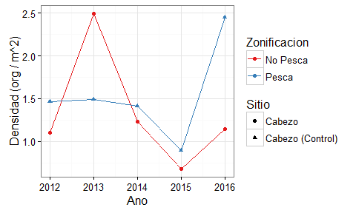

Densidad promedio de peces (org / m^2).

% Table created by stargazer v.5.2 by Marek Hlavac, Harvard University. E-mail: hlavac at fas.harvard.edu % Date and time: mi., sep. 07, 2016 - 15:27:16

## Riqueza

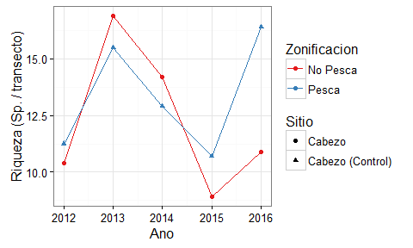

Riqueza promedio de peces (Sp / transecto).

% Table created by stargazer v.5.2 by Marek Hlavac, Harvard University. E-mail: hlavac at fas.harvard.edu % Date and time: mi., sep. 07, 2016 - 15:27:22

## Biomasa

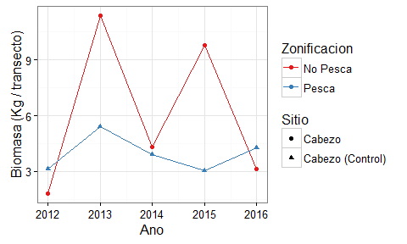

Biomasa promedio de peces (Kg / transecto).

% Table created by stargazer v.5.2 by Marek Hlavac, Harvard University. E-mail: hlavac at fas.harvard.edu % Date and time: mi., sep. 07, 2016 - 15:27:26

## Nivel trofico

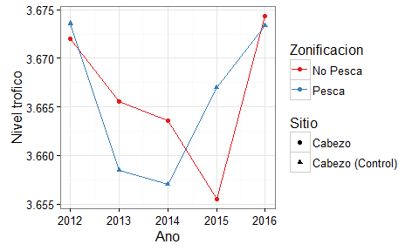

Nivel trofico promedio de peces.

% Table created by stargazer v.5.2 by Marek Hlavac, Harvard University. E-mail: hlavac at fas.harvard.edu % Date and time: mi., sep. 07, 2016 - 15:27:32

## Densidades por Nivel trofico

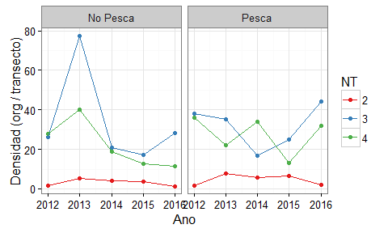

Proporciones de nivel trofico (org / transecto)

# Invertebrados

## Densidades

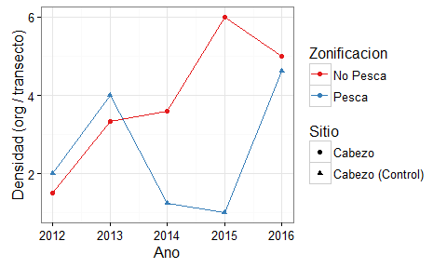

Densidad promedio de invertebrados (org / transecto).

% Table created by stargazer v.5.2 by Marek Hlavac, Harvard University. E-mail: hlavac at fas.harvard.edu % Date and time: mi., sep. 07, 2016 - 15:27:43

# Especies de interes

## Langosta (*Panulirus argus*)

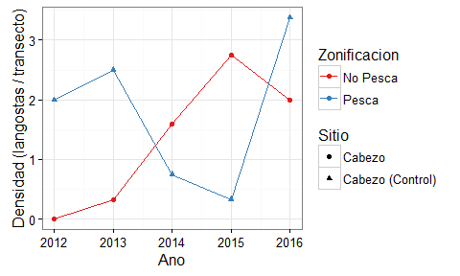

Densidad promedio de langosta (*Panulirus argus*; org / transecto).

% Table created by stargazer v.5.2 by Marek Hlavac, Harvard University. E-mail: hlavac at fas.harvard.edu % Date and time: mi., sep. 07, 2016 - 15:27:50

## Caracol rosa (*Lobatus gigas*)

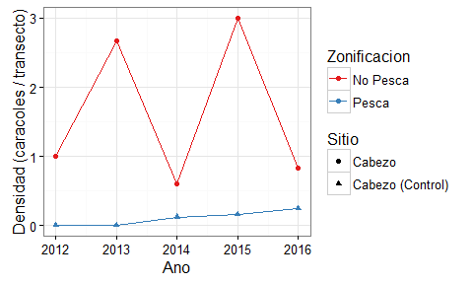

Densidad promedio de caracol rosa (*Lobatus gigas*; org / transecto)

% Table created by stargazer v.5.2 by Marek Hlavac, Harvard University. E-mail: hlavac at fas.harvard.edu % Date and time: mi., sep. 07, 2016 - 15:27:58

## Pargos (*Lutjanus sp.*)

### Densidad

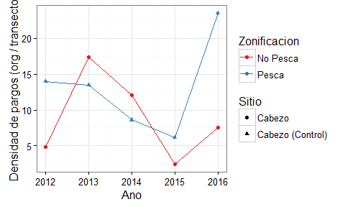

Densidad promedio de pargos (*Lutjanus sp.; org / transecto*)

% Table created by stargazer v.5.2 by Marek Hlavac, Harvard University. E-mail: hlavac at fas.harvard.edu % Date and time: mi., sep. 07, 2016 - 15:28:04

### Biomasa

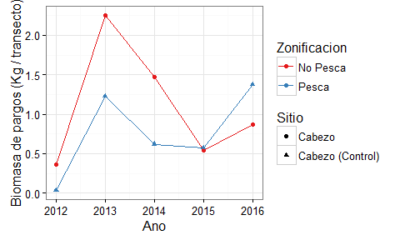

Densidad promedio de pargos (*Lutjanus sp.; Kg / transecto*)

% Table created by stargazer v.5.2 by Marek Hlavac, Harvard University. E-mail: hlavac at fas.harvard.edu % Date and time: mi., sep. 07, 2016 - 15:28:10

**Referencias**

* R Core Team (2015). R: A language and environment for statistical computing. R Foundation for Statistical Computing, Vienna, Austria. URL <https://www.R-project.org/>.
* JJ Allaire, Joe Cheng, Yihui Xie, Jonathan McPherson, Winston Chang, Jeff Allen, Hadley Wickham, Aron Atkins and Rob Hyndman (2016). rmarkdown: Dynamic Documents for R. R package version 0.9.6. <https://CRAN.R-project.org/package=rmarkdown>
* Hadley Wickham and Romain Francois (2016). dplyr: A Grammar of Data Manipulation. R package version 0.5.0. <https://CRAN.R-project.org/package=dplyr>
* Hadley Wickham (2016). tidyr: Easily Tidy Data with spread() and gather() Functions. R package version 0.6.0. <https://CRAN.R-project.org/package=tidyr>
* Hlavac, Marek (2015). stargazer: Well-Formatted Regression and Summary Statistics Tables. R package version 5.2. <http://CRAN.R-project.org/package=stargazer>